|  |  |
| --- | --- |
| Name: | Krunal Vasoya |
| Enrolment No.: | 91700103076 |
| Branch: | Computer Engineering |
| Class: | 8TC1 |
| Subject Code: | [01CE0804](https://www.marwadiuniversity.ac.in/wp-content/uploads/2019/01/01ce0804-machine-learning-3.pdf) |
| Subject Name: | Machine Learning |

# Exp 7: L1- Regularization and L2- Regularization(Lasso Regression and Ridge Regression)

**AIM:** To Understand and Implement L1 and L2 Regularization techniques.

**Problem Description:**

To implement and understand these techniques we have the House Prices dataset. The data contains 21 different independent variables like bedrooms, sqft_living, view, grade, etc and the dependent variable is the price. Both L1 and L2 regularization aims to optimize the residual sum of squares (RSS) plus a regularization term. First, we will do this for alpha = 10(chosen randomly), and then we will use cross-validation to estimate the optimal alpha that produces the minimum RMSE.

**Procedure:**

1. Import the required Libraries
2. Import and Load the Dataset
3. Identify and use independent variables which have a good correlation with the dependent variable ‘price’.
4. Split the Dataset into Train and Test Data
5. Implement Lasso Regression for alpha = 10 and print RMSE value
6. Plot the RMSE of Lasso Regression as alpha scales
7. Print the Optimal Alpha value for Lasso Regression and its corresponding RMSE
8. Repeat Steps from 5 to 7 for Ridge Regression.

**Results:**

1. **L1 Regularization - Lasso Regression**

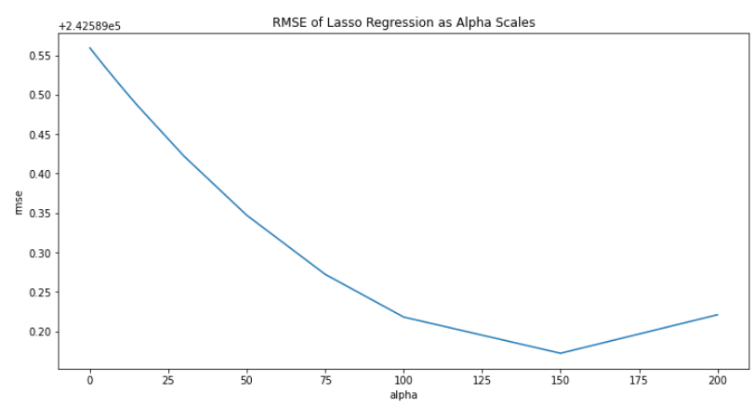



1. **L2 Regularization - Ridge Regression**



